

***Biology Teacher (September 2023)***

***Cheltenham College***

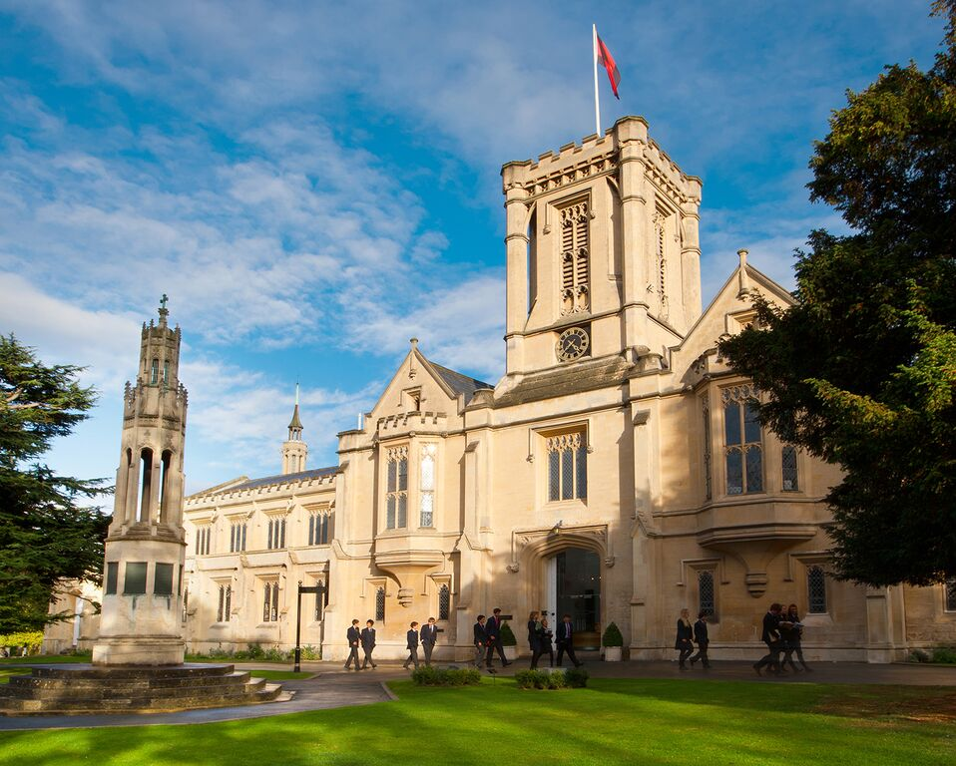

If you would like to discuss the role informally, please contact the HR Department on   
01242 265670 or by email at recruitment@cheltenhamcollege.org.

The closing date for applications is: **9am on Tuesday, 7th February**

Interviews are scheduled to take place: Friday, 10 February

***College is committed to safeguarding and promoting the welfare of children and young people in its recruitment and selection of job applicants and expects all staff and volunteers to share this commitment. The successful candidate will be required to undergo an enhanced DBS check.***

**Message from the Head of Cheltenham College, Nicola Huggett**

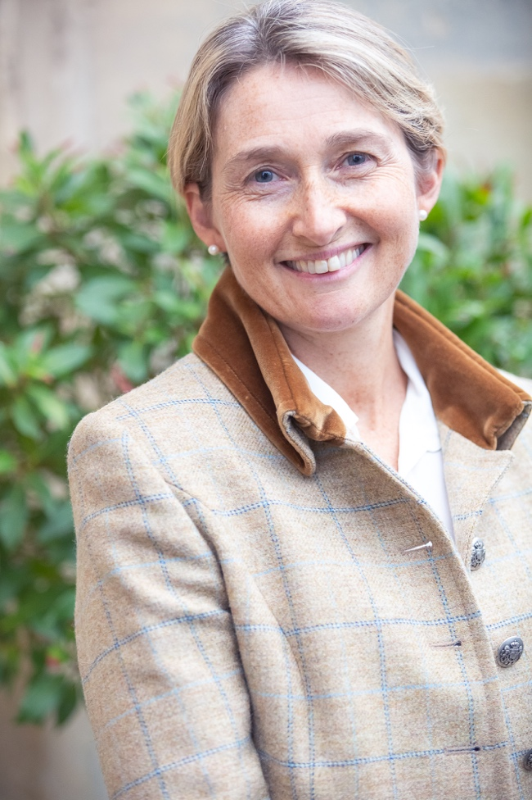

I am delighted that you are considering a role here at Cheltenham College. I hope that you find this information helpful and we would welcome your application.

The College lies in the heart of one of the country’s most beautiful Regency spa towns, only a few short miles from the rural delights of the Cotswolds. This means that as a place to live and work, you truly have the best of both worlds; a cosmopolitan centre with wonderful restaurants, shops and of course, four major cultural festivals a year, in addition to easy access to walks, country pubs and the great outdoors. Having recently moved to Cheltenham myself just a few years ago, with my husband and four children, I can assure you that there is something for everyone here.

Cheltenham College is a thriving community, with over 1100 pupils from the Prep and Senior Schools combined, cared for by 600 support and academic staff. We have high class facilities for academic development, boarding, sport, music and drama, as well as a truly awe-inspiring chapel. We are a 24/7 operation, working a six-day week with Saturday school. With our focus on full boarding (80% of our pupils are boarders) we are able to get to know our pupils very well and that makes inspiring them in and outside the classroom all the more enjoyable.

As staff, we enjoy the very wide range of activities that our pupils enjoy, with access to wonderful sports facilities for you and your family, a beautiful Common room, full IT provision, a thriving staff consultation committee and many staff social events. You will also have a tailored professional development programme and extensive support from our dedicated HR team.

Whilst we may seem a large organisation, we operate very much as a close community with a family feel. I know that as a new member of staff you will find that our focus lies very much in developing you as an individual. Just as we expect you to go the extra mile for your pupils, we will engage with your own professional and personal development from the start. We will ensure that you enjoy and feel valued in your new role as quickly as possible.

We recognise the time and thought that goes into an application and we will certainly give this our serious consideration. If you have any further questions, the HR department via [recruitment@cheltenhamcollege.org](mailto:recruitment@cheltenhamcollege.org) will be happy to help.

With best wishes

**SENIOR SCHOOL (13-18)**

**TEACHER OF BIOLOGY**

**The Biology Department**

This is a fantastic opportunity for an enthusiastic Biologist to join a large, successful and talented department and faculty. The post would suit equally an experienced teacher looking for a new challenge, or a teacher beginning their career. The department would be able to provide the requisite support for an NQT, and the school has its own bespoke staff induction program. It is expected the successful candidate will teach across the full ability and age range.

College's national and international profile is excellent, and the profile of Science has grown significantly in recent years, culminating in the £3 million refurbishment of the Science facilities. Pupil achievement and attainment in Biology is excellent; exam results are strong and students regularly go on to Oxbridge, Russell Group and international universities.

Pupils are encouraged to develop a passion for the subject, and for Science in general, developing a sense of genuine curiosity and aspiration. The department runs a programme to prepare candidates for Medicine, Dentistry and Veterinary Science and is currently preparing College students, alongside students from our community partnership schools, for university admission both in and outside of the United Kingdom. The Science department hosts lectures delivered by both external and internal speakers – most recently, Tom Crawford, Mark Miodownik, David Nott (through the Literature Festival) and Adam Hart. Pupils are offered the opportunity to attend conferences at universities and undertake research at laboratories in the local area. The Biology department run the Biology Olympiad and Biology Challenge, with strong representation at both awards. The Biology department also supports students wishing to study at Oxbridge and Russell group universities through a unique and successful mentoring programme.

The department members are always looking to emphasize the enjoyment and relevance of the subject, and this, naturally, makes the department a lively and interesting place. Practical work is at the very heart of the subject and the six teachers are well supported by a talented technician team.

The department is housed in the re-furbished Science building and consists of five teaching laboratories, with a dedicated prep room and departmental library. The department has a large wealth of resources and has invested in a number of innovative online tools. The appropriate use of technology is always encouraged, and each classroom has wireless connectivity to the school network. Each member of staff is provided with an Apple MacBook and an iPad, and all the teaching laboratories have TVs and visualizers.

Biology is taught as a separate subject in the Lower College (NC years 9-11), and the Edexcel IGCSE course is started in the Third Form (NC Y9). In the Sixth Form pupils follow the OCR A Biology specification. Uptake of all three Sciences at A Level is strong with each department running multiple Sixth Form sets each year. Additionally, the department benefits from students joining from schools both in and out of the United Kingdom to complete their Sixth Form education.

**The Post:**

A Teacher of Biology at College is responsible, through the Head of Biology and the Head of Science, for the teaching of Biology to pupils according to the curricula for each year group. Promotion of the values of Cheltenham College is integral to the role, and it is essential that the successful candidate is a good role model for the pupils and prepares them to make a positive contribution to society.

The successful candidate will be accountable to the Head of Biology for the quality of their teaching, and will offer opportunities for pupils to develop, along with providing regular feedback on any pupil, staff or organisational issue. They will also show an enthusiasm for the subject, and for the art of teaching. They will take responsibility for several classes across the age and ability range of the school, and expectations will include, but not be limited to, the following:

* Teach a full timetable of Biology across the ability and age range (currently twenty-seven 40-minute lessons per week).
* Demonstrate an excellent subject knowledge and show enthusiasm to learn themselves. They will also be expected to reflect on their own practice to allow personal development.
* Knowledge of the OCR A A-Level Biology specification is desirable.
* Set and mark work, and provide regular written and verbal feedback to pupils in-line with the College and Departmental policies.
* Monitor national and international curriculum developments, and attend training as offered by the examination bodies.
* Take agreed responsibility for an area of the College curriculum within the department, and ensure that the scheme of work is up to date.
* Deliver guidance to A-Level candidates on the completion of practical work and provide regular written feedback.
* Liaise with departmental technical staff to ensure the correct planning and delivery of practical work.
* Communicate with parents over pupil progress both at parents’ meetings and via email or telephone when appropriate.
* Show evidence of and have an interest in professional and personal development. There will be the scope to attend relevant training courses and conferences.
* Share resources, and share “best practice” with the rest of the department.
* Participate in the College’s PPD professional development programme.

The opportunity to be involved in a boarding house in a residential capacity may be available. This would constitute a chance to gain superb pastoral experience. Candidates who are interested in such an opportunity should make this clear in any letter of application.

**Expectations**

Members of Common Room are expected to teach their subject[s], to act as tutors, to be attached to day or boarding Houses, to make a substantial contribution to the co-curricular programme and to support the boarding ethos of the College. Outside of the formal term times they are expected to be in College for College or departmental INSET and to be available to fulfil any reasonable duties.

**The College sets the highest professional standards in every respect.**

**Terms and Conditions:**

* A full-time teacher has approximately 27 lessons per week of forty minutes and is expected to be a tutor (involving 2 periods a week and reflection meetings with tutees every fortnight), undertake duties and to play an appropriate part in the co-curricular life of the College.
* The College has its own salary scale.
* College offers a defined contribution Workplace Pension Plan plus a Flexible Benefits Pot. The scheme offered is through APTIS: Aviva Pensions Trust for Independent Schools and includes a generous College contribution.
* Accommodation may be available.
* Permanent members of staff are entitled to a substantial reduction in fees for their children.
* Members of staff may use the College sports facilities (at staff allocated times).

**November 2022**